**Week 6 Activity - Group C4**

**Members:**

Vithursh Thananchayan

Ashwin B N  
Justin Villaspir  
David Rivera  
  
  
1. User Story

As the Scheduling Coordinator, I am responsible for ensuring that all classes at ProTKD Martial Arts and Fitness are adequately staffed with instructors. My role involves balancing instructor schedules, managing class availability, and preventing scheduling conflicts. I need a reliable system that simplifies this process by allowing me to quickly view unassigned classes and check teacher availability. The system should help me ensure that instructors are appropriately assigned, which must provide a smooth operation of classes and overall customer satisfaction.

2. Activity Diagram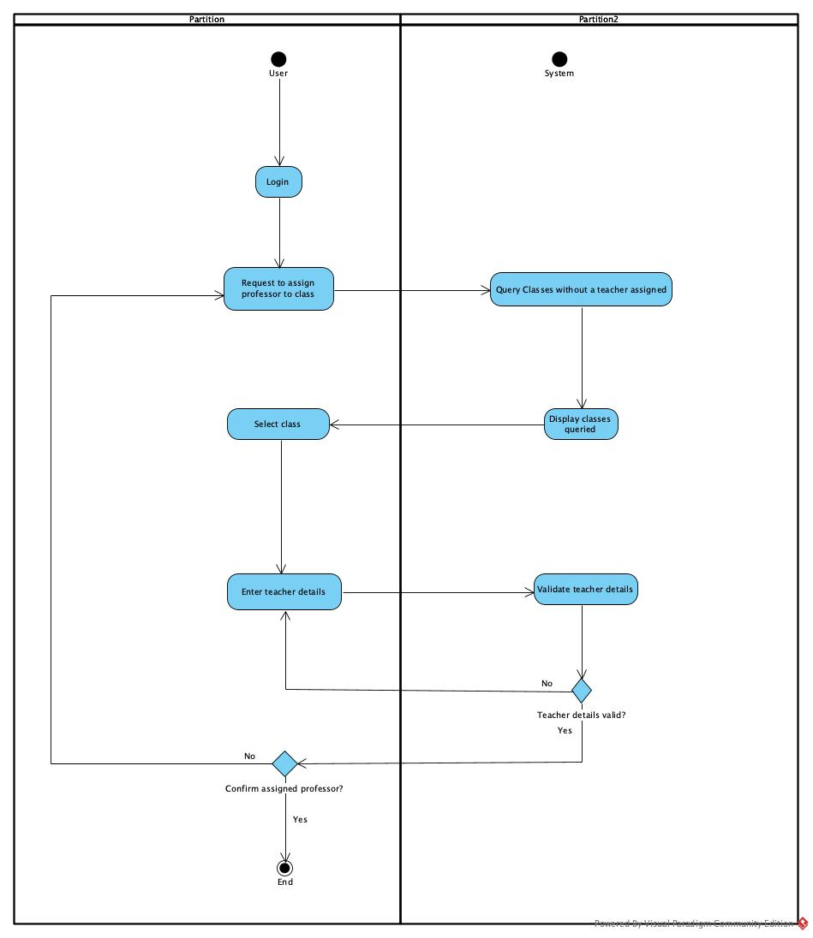

3. UI design

Link: <https://wireframe.cc/pro/pp/9ed925fc7830792>

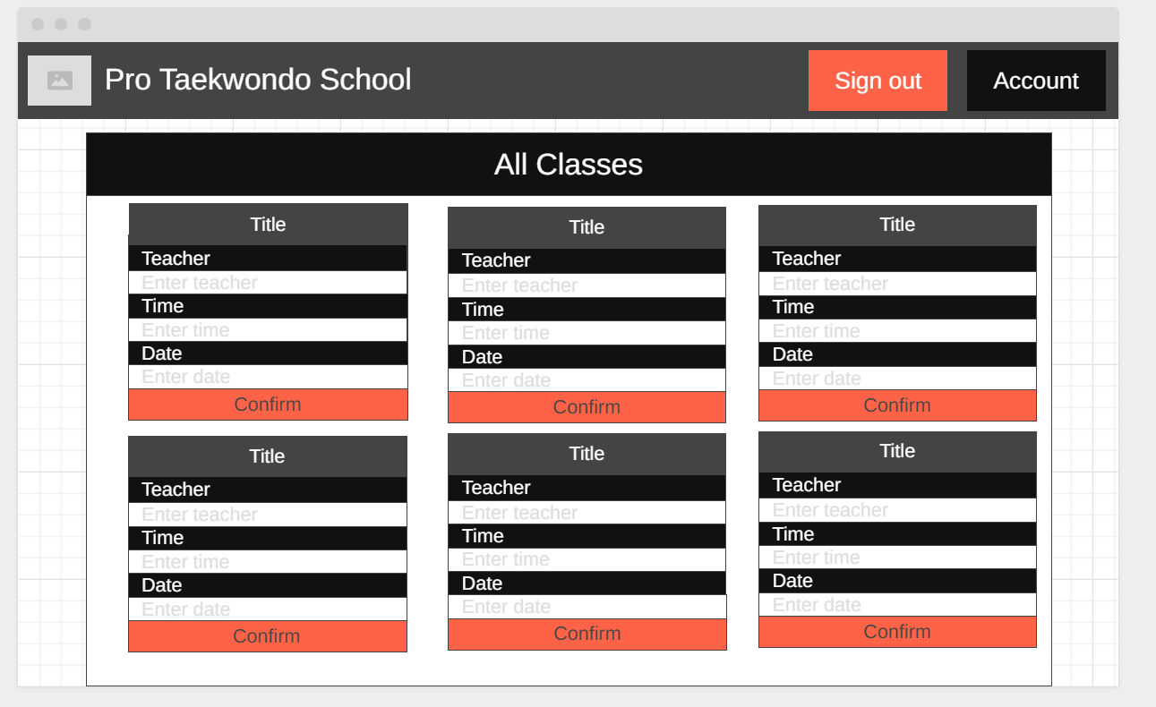

4. Use Case Specification(Scheduling Teacher to Class Use Case)

| Use Case Name | | | Scheduling Teacher to Class |
| --- | --- | --- | --- |
| Triggering Event | | | The scheduling staff logs into the system and selects the option to assign teachers to classes |
| Brief Description | | | This use case allows scheduling staff to assign available teachers to classes, set class times, and ensure that no scheduling conflicts exist. |
| Actors | | | Scheduling staff |
| Related Use Cases | | | Class registration, Instructor availability management |
| Preconditions | | | The scheduling staff must have access to the scheduling system |
| Post Conditions | | | The selected classes are successfully scheduled with assigned teachers |
| Flow of activities | Actor | | System |
|  | 1. | Request to schedule a class | Displays all classes that do not have a teacher assigned to it |
|  | 2. | Selects class | Prompts for name of teacher and date and time the class will occur |
|  | 3. | Enters teachers name, date and time | Data Validation:  name must be entered  date must be entered  time must be entered  check if teacher is already assigned to another class  Data is valid |
|  | 4. | Confirm scheduled class | Data is saved |
|  | 5. | Chooses to exit | Displays the home page |
| Exception Conditions | · The scheduling staff chooses to cancel the class being scheduled | | |

5. Class Diagram

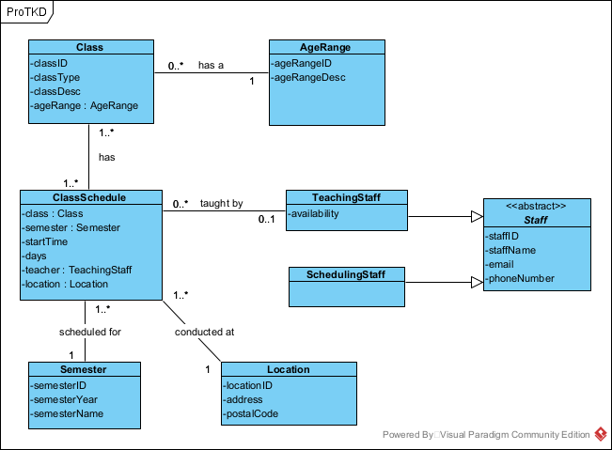

6. Object Level Sequence Diagram

